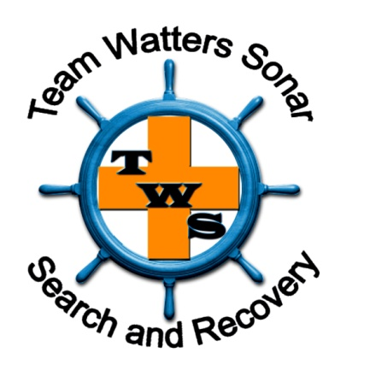

Awards & Recognitions:
Certificate of Appreciation
- From: Kansas City, Missouri Police Department
- When: June 29, 2017
- For: Meritorious service rendered to Kansas City, Missouri Police Department in the location of missing person Toni Anderson and her vehicle
- Where: Kansas City, Missouri
Ohio’s Finest Civilian Award 2015
- From: Fraternal Order of Police of Ohio Foundation
- When: June 19, 2015
- For: The hard work and our dedication to finding missing person Tony Luzio Jr
- Where: Columbus, Ohio
Certificate of Commendation
- From: Ohio Secretary of State Jon Husted
- When: June 19, 2015
- For: Receiving the Ohio’s Finest Civilian Award 2015
- Where: Columbus, Ohio
Civilian Citation
- From: The Buckeye State Sheriff’s Association
- When: February 9, 2015
- For: The hard work and dedication on the missing person case of Tony Luzio Jr
- Where: Columbus, Ohio
Letter of Thanks
- From: Delaware County Sheriff’s Office: Detective Jeff Bessinger
- When: February 9, 2015
- For: The assistance in resolving the missing person case of Tony Luzio jr
- Where: Columbus, Ohio
Letter of Thanks
- From: Delaware County Sheriff’s Office: Sheriff Russell martin
- When: October 24, 2014
- For: Our dedication and hard work assisting them on the disappearance of Tony Luzio Jr, located car and victim on October 21, 2014 [missing 9 ½ years]
- Where: Columbus, Ohio
Letter of Thanks
- From: Illinois Department of Natural Resources; Conservation Officer Tim Lay
- When: June 6, 2012
- For: Locating drowning victim of a boating accident on Rend Lake
- Where: Sesser, Illinois
Letter of Thanks
- From: Columbia County Sheriff’s Office; LT Chuck Brewington
- When: February 3, 2012
- For: located December drowning victim and stayed over to train them on their Side Image Sonar unit
- Where: Olustee, Florida
Letter of Gratitude
- From: St Charles Parrish Sheriff’s Office; Sheriff Greg Champagne
- When: March 9, 2011
- For: Located drowning victim in the Mississippi River
- Where: New Orleans, Louisana
Letter of Thanks
- From: Madison County Sheriff’s Office; Sheriff Robert Hertz
- When: June 19, 2010
- For: Locating drowning victim in Holiday Shores Lake
- Where: Holiday Shores, Illinois
Certificate of Appreciation
- From: Tennessee Bureau of Investigation
- When: January 2, 2010
- For: Assisting in a homicide investigation
- Where: Savannah, Tennessee
Letter of Thanks
- From: Collins County Sheriff’s Office; Major Chuck Ruckel
- When: January 11, 2010
- For: locating drowning victim
- Where: McKinney, Texas
Letter of Thanks
- From: Texas Parks & Wildlife; Captain Gary Dugan
- When: December 12, 2008
- For: Located drowning victim in Richland Chambers Lake
- Where: Corsicana, Texas
Letter of Thanks
- From: Texas Parks & Wildlife; Captain Garry Collins
- When: December 8, 2008
- For: locating drowning victim in Ray Hubbard Lake
- Where: Garland, Texas

Letter of Thanks
- From: Oklahoma Department of Public Safety; Chief of Patrol Van Guillotte
- When: October 2, 2007
- For: Assisted Oklahoma Highway patrol in locating and recovering missing boat from boating accident on Kaw Lake
- Where: Kaw, Oklahoma
Volunteer of the Year Award
- From: Texas EquuSearch
- When: June 2007
- For: Outstanding Dedication and Support
- Where: Houston, Texas
Certificate of Appreciation
- From: Illinois Department of Natural Resources
- When: March 22, 2007
- For: Located 8-year-old drowning victim from a boating accident on Clinton Lake
- Where: Clinton, Illinois
- Also received Thank You letters from Illinois Department of Natural Resources Director Rafael Guitierrez and from the Mt Moriah Christian Church
In Appreciation Award
- From: Salem Fire Department
- When: August 12, 2006
- For: Giving our time to enhance their ability to use side image sonar[training]
- Where: Salem, Wisconsin
Outstanding Citizen Award
- From: Southwestern Illinois Law Enforcement Commission & Southern Illinois Police Chief’s Association
- When: January 18, 2006
- For: May 2005 located vehicle with missing retired school teacher who had been missing for years in the Mississippi River
- Where: Alton, Illinois
- Received Thank You letter from Alton Chief of Detectives David Hayes
- Received a Congratulation letter from House of Representative Jerry Costello in January 2006 for receiving the Outstanding Citizen’s Award

